Spark Interview Questions and Answers
Basic Questions
- What is Apache Spark?
Apache Spark is an open-source, distributed data processing engine used for big data processing and analytics.
It allows data processing in batch and real-time using in-memory computation to increase performance.
- What are the key components of Apache Spark?
The main components are:
  - Spark Core – Basic functionality and scheduling.
  - Spark SQL – For structured data processing using SQL.
  - Spark Streaming – For real-time data processing.
  - MLlib – Machine learning library.
  - GraphX – For graph processing.
- Explain RDD (Resilient Distributed Dataset).
RDD is the fundamental data structure in Spark that allows distributed data storage and parallel processing. It is:
  - Immutable
  - Lazily evaluated
  - Fault-tolerant
- What is the difference between DataFrame and Dataset in Spark?
  - DataFrame – Collection of rows and columns (like a table), optimized using Catalyst optimizer.
  - Dataset – Strongly typed, object-oriented collection, better for compile-time type checking and more structured transformations.
- What is the difference between Spark and Hadoop?
  - Spark is faster because of in-memory computation.
  - Spark supports real-time processing, while Hadoop is batch processing.
  - Spark uses DAG (Directed Acyclic Graph) for execution, whereas Hadoop uses MapReduce.
Directed – The edges between nodes have a direction, meaning they go from one node to another in a specific order.
Acyclic – There are no cycles, which means you cannot start at one node and follow the directed edges back to the same node

Intermediate Questions
- What is the significance of Spark Context?
Spark Context is the entry point for Spark functionality. It establishes connection with the Spark cluster and enables the execution of Spark applications.
- What is a DAG (Directed Acyclic Graph) in Spark?
DAG is a sequence of computations where each node represents an RDD transformation, and edges represent the flow of data. Spark creates a DAG before execution.
- Explain the difference between map() and flatMap() in Spark.
  - map() – Transforms each element of the RDD and returns a new RDD with the same number of elements.
  - flatMap() – Similar to map(), but it flattens the output, returning a new RDD with possibly more or fewer elements.

IN Apache Spark, both map() and flatMap() are used for transforming data in an RDD or DataFrame, but they work differently in how they handle the output:
map()
- map() applies a function to each element in the dataset and returns a new dataset where each input element produces exactly one output element.
- Output structure is 1-to-1.
- Output is wrapped as an RDD of collections if the function returns a collection.
✅ Example:
rdd = sc.parallelize([1, 2, 3, 4])
result = rdd.map(lambda x: [x, x * 2])
result.collect()
# Output: [[1, 2], [2, 4], [3, 6], [4, 8]]
2. flatMap()
- flatMap() applies a function to each element and returns zero or more elements for each input element.
- Output structure is 1-to-many.
- The result is flattened into a single collection.
✅ Example:
python
CopyEdit
rdd = sc.parallelize(["hello world", "spark rdd"])
result = rdd.flatMap(lambda x: x.split(" "))
result.collect()
# Output: ['hello', 'world', 'spark', 'rdd']

- What are the different types of transformations in Spark?
  - Narrow Transformations – No data shuffling between partitions (e.g., map, filter).
A narrow transformation is a type of transformation where:
✅ The data required to compute the records in a single partition resides in a single parent partition.
✅ No data shuffling happens between partitions.
✅ Each output partition depends on a single input partition.
✅ These transformations are faster because they do not require data movement across nodes

rdd = sc.parallelize([1, 2, 3, 4, 5])
result = rdd.filter(lambda x: x % 2 == 0)
print(result.collect())
# Output: [2, 4]

rdd1 = sc.parallelize([1, 2, 3])
rdd2 = sc.parallelize([4, 5, 6])
result = rdd1.union(rdd2)
print(result.collect())
Wide Transformations – Data shuffling happens across partitions (e.g., groupByKey, reduceByKey).

A wide transformation is a type of transformation where:
✅ Data is shuffled across the network between multiple partitions.
✅ The output partition depends on multiple input partitions.
✅ Spark creates a new stage in the execution plan to accommodate the data shuffling.
✅ They are expensive and slower compared to narrow transformations due to network I/O and data movement

rdd = sc.parallelize([('a', 1), ('b', 2), ('a', 3), ('b', 4)])
result = rdd.groupByKey().mapValues(list)
print(result.collect())
# Output: [('a', [1, 3]), ('b', [2, 4])]

rdd1 = sc.parallelize([('a', 1), ('b', 2)])
rdd2 = sc.parallelize([('a', 3), ('b', 4)])
result = rdd1.join(rdd2)
print(result.collect())
# Output: [('a', (1, 3)), ('b', (2, 4))]

coalesce()
- Reduces the number of partitions in an RDD without shuffling.
- If shuffle=True is specified, data will be reshuffled to rebalance partitions
rdd = sc.parallelize([1, 2, 3, 4, 5, 6], 3)
result = rdd.coalesce(2, shuffle=True)
print(result.collect())

- How does Spark achieve fault tolerance?
→ Spark achieves fault tolerance using lineage and DAG. If a partition fails, Spark recomputes the lost data using lineage information.

Advanced Questions
- How does Spark optimize data processing?
- Catalyst Optimizer – For logical and physical query optimization.
- Tungsten Execution Engine – Improves execution performance using whole-stage code generation and memory management.
- What is a Broadcast Variable in Spark?
A broadcast variable allows data to be shared across nodes without sending it multiple times, reducing network latency.
A Broadcast Variable in Spark allows you to efficiently distribute large, read-only data sets (such as lookup tables) across all the worker nodes.

- What is an Accumulator in Spark?
→ An accumulator is used to aggregate values across the cluster (e.g., counting or sum operations).
An Accumulator in Apache Spark is a special type of shared variable used for aggregating data across multiple nodes in a distributed environment. It allows Spark to efficiently update values in parallel during the execution of a Spark job while ensuring that updates are only performed once.

How Accumulators Work Internally
- Spark creates the accumulator on the driver.
- Each worker node gets a local copy of the accumulator.
- Tasks running on different nodes update the local copies of the accumulator.
- At the end of the task execution, Spark merges all local accumulator values back into the accumulator in the driver

from pyspark.sql import SparkSession

# Create SparkSession
spark = SparkSession.builder.appName("AccumulatorExample").getOrCreate()

# Create an accumulator
accum = spark.sparkContext.accumulator(0)

# Sample data
data = [1, 2, 3, 4, 5, 6, 7, 8, 9, 10]
rdd = spark.sparkContext.parallelize(data)

# Function to update accumulator
def count_even(num):
if num % 2 == 0:
accum.add(1)

# Apply the function
rdd.foreach(count_even)

# Access the accumulator value (on the driver)
print(f"Number of even numbers: {accum.value}")

# Output: Number of even numbers: 5

- How do you handle skewed data in Spark?
- Salting the keys
from pyspark.sql import functions as F

# Add salt to the key to distribute data more evenly
df = df.withColumn("salted_key", F.concat(F.col("key"), F.lit("_"), (F.rand() * 10).cast("int")))

# Use salted key for joins
joined_df = df1.join(df2, df1["salted_key"] == df2["salted_key"], "inner")
- Increasing shuffle partitions
df = df.repartition(100) # Increase partitions to 100
- Using broadcast join for small tables
from pyspark.sql.functions import broadcast

small_df = broadcast(small_df)
joined_df = large_df.join(small_df, "key")
- Explain checkpointing in Spark.
→ Checkpointing allows saving an RDD to persistent storage, ensuring that data is not recomputed if the job fails.

1. What is Azure Databricks?
→ Azure Databricks is a fast, easy-to-use, and collaborative Apache Spark-based analytics platform designed for big data and AI. It integrates with Azure services like Data Lake, Blob Storage, and Synapse for seamless data processing and machine learning.

2. What are the main components of Azure Databricks?
- Workspace – Environment to create and manage Databricks objects.
- Clusters – Distributed computing infrastructure for executing Spark jobs.
- Notebooks – Interactive coding environment for writing Spark code.
- Jobs – For scheduling and executing Spark workloads.
- Libraries – External packages and dependencies.
- Delta Lake – Storage layer for ACID transactions.

3. What are the benefits of using Azure Databricks?
- High-performance data processing using Apache Spark.
- Integration with Azure ecosystem (Data Lake, Blob Storage, Synapse).
- Scalable infrastructure for ML and AI models.
- Support for multiple programming languages (Python, Scala, R, SQL).
- Collaboration through interactive notebooks.

4. What is the difference between Databricks and Spark?
Feature | Databricks | Spark
Deployment | Managed by Azure | Self-hosted or cloud-based
Performance | Optimized for Azure | Depends on cluster setup
Integration | Deep integration with Azure services | Requires manual setup
Ease of Use | Interactive UI and Notebooks | Command-line or scripts

5. What languages are supported in Azure Databricks?
→ Python, Scala, Java, R, and SQL.

Intermediate Questions
6. How is Azure Databricks integrated with Azure services?
- Azure Data Lake – For data storage.
- Azure Blob Storage – For unstructured data storage.
- Azure Synapse – For data analysis and reporting.
- Azure Machine Learning – For ML model deployment.
- Azure Key Vault – For managing secrets and credentials.

7. Explain the concept of a Databricks Cluster.
→ A Databricks cluster is a set of virtual machines configured to run Spark-based workloads. It consists of:
- Driver Node – Manages job execution.
- Worker Nodes – Execute tasks and store data.

8. What is the difference between a Job Cluster and an Interactive Cluster?
- Job Cluster – Created for a single job; terminated after job completion.
- Interactive Cluster – Created for development and testing; remains active until manually terminated.

9. Explain Databricks Delta Lake. Why is it important?
→ Delta Lake is a storage layer that enables ACID transactions, scalable metadata handling, and time travel on top of data lakes. It ensures:
✅ Data reliability through schema enforcement
✅ Data consistency with transactional support
✅ Fast reads and writes with optimized data processing

10. What are the different modes of data ingestion in Azure Databricks?
- Batch Processing – Using Spark jobs and data pipelines.
- Streaming Processing – Using Spark Streaming.
- Manual Upload – Directly importing data into a notebook.
- Auto Loader – Automated ingestion from data lakes.

Advanced Questions
11. What are the different types of clusters in Databricks?
- Standard Clusters – For general-purpose workloads.
- High Concurrency Clusters – For serving multiple users concurrently.
- Single Node Clusters – For testing and debugging.
- Automated Clusters – Automatically created and terminated for jobs.

12. How does Databricks manage data security?
✅ Azure Active Directory for authentication.
✅ Role-Based Access Control (RBAC).
✅ Secure cluster connectivity using Private Link.
✅ Data encryption at rest and in transit.
✅ Network isolation with virtual network integration.

13. Explain the difference between Parquet and Delta file formats in Databricks.
Feature | Parquet | Delta
Transactional Support | ❌ No | ✅ Yes
Schema Evolution | ❌ No | ✅ Yes
ACID Transactions | ❌ No | ✅ Yes
Performance | Good | Optimized for reads and writes

14. How can you improve performance in Azure Databricks?
✅ Use Delta Lake for faster reads and writes.
✅ Optimize partitioning strategies.
✅ Use caching to reduce computation time.
✅ Enable Auto Scaling for cluster sizing.
✅ Optimize join strategies using broadcast joins.

15. What are some challenges you faced while working with Azure Databricks? How did you resolve them?
👉 Challenge: Slow data ingestion due to large files
Solution:
- Partitioned data for parallel processing.
- Used Auto Loader for faster streaming ingestion.
- Increased cluster size for better throughput.
👉 Challenge: Schema evolution issues in Delta Lake
Solution:
- Enabled schema evolution.
- Configured merge strategies for handling conflicts.

Scenario-Based Questions
16. How would you handle a failing Databricks job in production?
→ Steps to resolve:
- Check cluster logs for errors.
- Validate data input.
- Adjust timeout or partitioning settings.
- Resubmit the job with increased cluster size.

17. How would you implement incremental data loading in Databricks?
→ Use Delta Lake MERGE strategy:
- Load data into a staging table.
- Apply MERGE command to update or insert records.
- Optimize partitioning to reduce data movement.

18. How do you manage large-scale machine learning models in Databricks?
- Use MLflow for model tracking and versioning.
- Leverage distributed training across multiple nodes.
- Optimize feature engineering using Spark SQL and Python.

19. How would you automate Databricks jobs using Azure Data Factory?
✅ Create a Databricks-linked service in ADF.
✅ Configure a pipeline to execute Databricks notebooks.
✅ Set up triggers for scheduling.
✅ Monitor execution using ADF logs.

20. How can you secure sensitive data in Databricks?
- Store credentials in Azure Key Vault.
- Use RBAC for access control.
- Enable network isolation using VNET integration.
- Encrypt data using Azure-managed keys.

Azure Databricks Interview Questions and Answers
- What is Azure Databricks?
Answer:
Data bricks is cloud-based data engineering/Data science/ML Build on top of Spark. Its collabarative workspace
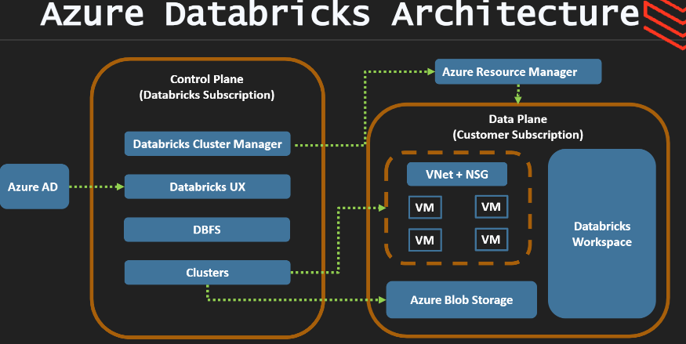
Data lake : is a centralized repository where we can store structured/Unstructured data.
Delta Lake: Data lake is open source on top of data lake. It provides ACID Properties. Delta lake provides schema enforcement, versioning and data indexing
Parquest files with transaction log to support ACID
Lakehouse: is the combination of the best features from warehouse/data lake. A Lakehouse build on top of delta lake supports Acid, fast analytics and data science.
Its having built in query engine to work on SQL Queries.
Data Bricks Clusters : Are set of computer resource
Databricks cluster configuration :Cluster node type,Auto scaling,Access Modek,databricks run time version,, Cluster VM Type,cluster policty, Acceleration mode

Cluster Node TYPE : Driver Node/Worker Node
Driver node : Maintain state information of all notebooks to attach the cluster. Maintain spark context, Interprets all commands, Runs apache spark master. Coordinates all worker nodes.
Worker node: Runs spark executors.
Access node type: Single user/Shared user/No isolation shared/custom

PHOTON : Photon available on Runtime 9.1 LTS and above.
Cluster VM type : Memory optimized/Compute Optimized/storage optimized/General purpose/GPU Accelarated
Data bricks pricing is based on compute usage. Measured DBU
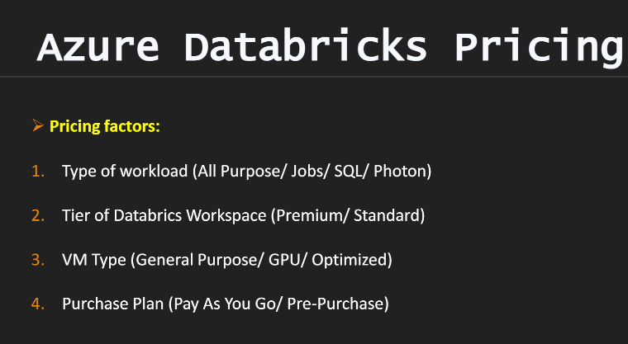

Cluster pool is used to reduce cluster start and auto scaling whenever required.

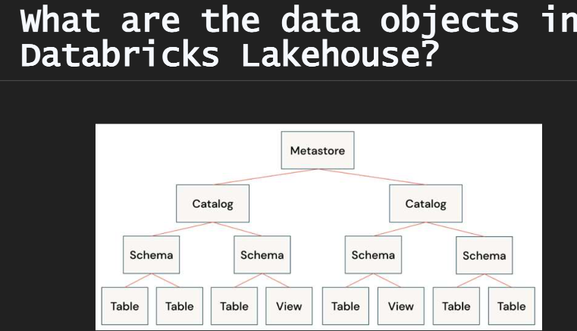
Unity Catalog: its metastore .it can be sharable across all workspaces
Hive metastore: Bult in metastore used as managed service.
External Meta store: we can bring our own meta store.
Ways to create management table :
Create table t1 as select * from t2, create table t1(colum datatype), dw. Write.saveAsTable(“t1”)
Ways to create Un managed table :
Create table t1 using delta location ‘/path/existing/data’
Create table t1 location ‘/path/existing’
dw.write.option(“path”,”pathoptions”).saveAsTable(“tablename”

CREATE TABLE employee AS
SELECT * FROM parquet.`${dataset.employee}/FileStore/extracted_files/employee_details/parquet_files`;
park.read.csv("abfss://bronze@gen2storage255.dfs.core.windows.net/bank_data.csv", header= True)
dbutils.fs.mount(
source = "abfss://<container-name>@<storage-account-name>.dfs.core.windows.net/",
mount_point = "/mnt/<mount-name>",
extra_configs = configs)

application_id = dbutils.secrets.get(scope="databricks-secrets", key="application-id")
tenant_id = dbutils.secrets.get(scope="databricks-secrets", key="tenant-id")
secret = dbutils.secrets.get(scope="databricks-secrets", key="secret")

bankdata_sdf.writeStream.format("delta").\
option("checkpointLocation", "/mnt/streaming-demo/streaming_dataset/bankdata_stream_sink/_checkpointLocation").\
start("/mnt/streaming-demo/streaming_dataset/bankdata_stream_sink")

CREATE STREAMING LIVE TABLE customers
COMMENT "The customers buying finished products, ingested from /databricks-datasets."
TBLPROPERTIES ("quality" = "mapping")
AS SELECT * FROM cloud_files("/mnt/retail-org/customers/", "csv");
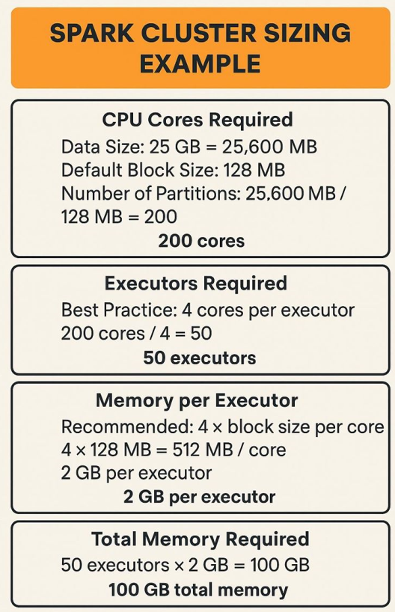

- Explain the architecture of Azure Databricks.
Answer:
  - Databricks is built on Apache Spark and integrates with Azure for storage (ADLS) and compute (VMs).
  - The control plane manages the cluster lifecycle and workspace.
  - The data plane processes the data and executes Spark jobs on clusters.
- What are the types of clusters in Databricks?
Answer:
  - Job Cluster – Created for a single job and destroyed after the job ends.
  - Interactive Cluster – Used for interactive workloads and shared across users.
- How does Databricks handle data storage?
Answer: Databricks does not store data directly; it integrates with ADLS, Blob Storage, and other external sources. Delta Lake is used for managing data storage in a structured format.
- What is Delta Lake in Databricks?
Answer: Delta Lake is an open-source storage layer in Databricks that brings ACID (Atomicity, Consistency, Isolation, Durability) transactions to Apache Spark data lakes.
- How to improve performance in Databricks?
Answer:
  - Use Delta Lake for data storage.
  - Optimize data using OPTIMIZE and ZORDER.
  - Use caching and data partitioning.
  - Minimize shuffling and increase parallelism.
PARTITIONING:
CREATE TABLE sales_data (
sale_id INT,
product STRING,
amount DOUBLE,
sale_date DATE,
country STRING
)
USING DELTA
PARTITIONED BY (country);
from pyspark.sql import SparkSession

# Create Spark session
spark = SparkSession.builder.appName("PartitionExample").getOrCreate()

# Sample data
data = [
(1, 'Laptop', 1200.00, '2024-02-01', 'USA'),
(2, 'Phone', 800.00, '2024-02-02', 'India'),
(3, 'Tablet', 600.00, '2024-02-03', 'Canada')
]

# Define schema
schema = ['sale_id', 'product', 'amount', 'sale_date', 'country']

# Create DataFrame
df = spark.createDataFrame(data, schema)

# Write data to Delta table with partitioning
df.write \
.format("delta") \
.mode("overwrite") \
.partitionBy("country") \
.save("/mnt/delta/sales_data")

Optimizing Data Using OPTIMIZE and ZORDER in Databricks
In Databricks, data can be optimized using the OPTIMIZE and ZORDER commands to improve query performance and reduce data scanning. These commands work primarily with Delta tables and help with file compaction and data skipping.

Why Use OPTIMIZE and ZORDER?
- OPTIMIZE – Combines smaller files into larger ones to improve read performance and reduce the number of files Spark needs to read.
- ZORDER – Organizes data based on specific columns to improve data locality and enable faster data pruning during querie

OPTIMIZE table_name
[WHERE condition]
OPTIMIZE sales_data;
How It Works:
✅ Reduces the number of files Spark needs to read
✅ Increases query parallelism
✅ Reduces I/O overhead
🔎 2. ZORDER Command
The ZORDER command sorts data based on specific columns to improve data skipping and minimize file scanning.
- ZORDER works within partitions after the OPTIMIZE command.
- It reduces the data scanned by grouping together rows with similar values.
OPTIMIZE table_name
ZORDER BY (column1, column2, ...);
OPTIMIZE sales_data
ZORDER BY (sale_date);

VACUUM in Databricks (Delta Lake)
The VACUUM command in Databricks is used to delete old, unreferenced Delta Lake files that are no longer needed for time travel or versioning. This helps to optimize storage and improve performance by removing unnecessary data files

Why Use VACUUM?
- Reduce Storage Costs – Deletes outdated files and optimizes storage usage.
- Improve Query Performance – Reduces the number of files read during queries.
- Maintain Data Hygiene – Prevents unnecessary accumulation of deleted or updated files.
- Optimize Delta Tables – Works well with OPTIMIZE and ZORDER for better query performance

VACUUM delta.`/mnt/data/sales` RETAIN 168 HOURS; in SQL
spark.sql("VACUUM delta.`/mnt/data/sales` RETAIN 168 HOURS") IN PYTHON

- Explain the difference between Databricks and Synapse.
Answer:
  - Databricks is ideal for large-scale data engineering and machine learning.
  - Synapse is more suited for SQL-based data warehousing and analytics.

Cluster Types and Sizing for Production Jobs in Azure Databricks
When configuring production jobs in Azure Databricks, selecting the right cluster type and size is critical for optimizing performance, cost, and reliability. The choice of cluster depends on workload type (batch, streaming, ML), data volume, and complexity of the operations.

✅ Types of Clusters in Azure Databricks
1. Job Clusters (Recommended for Production Jobs)
- Created when a job is started and terminated after the job finishes.
- Ideal for scheduled or triggered production jobs (ETL, data transformation).
- Cost-effective as it releases resources once the job completes.
Example Use Case:
- Nightly ETL jobs
- Data processing pipelines

2. All-Purpose Clusters
- Interactive clusters that remain active even after a job completes.
- Suitable for ad hoc analysis and exploratory work.
- Not ideal for production due to ongoing cost even when idle.
Example Use Case:
- Machine learning experiments
- Exploratory data analysis

3. High Concurrency Clusters
- Optimized for concurrent workloads.
- Designed for real-time data processing with low latency.
- Multiple users can share the same cluster simultaneously.
Example Use Case:
- Real-time analytics
- BI dashboards

✅ Sizing Recommendations Based on Workload
Workload Type | Cluster Size | Configuration | Use Case
Small ETL Jobs | 4–8 cores | 1 Driver, 2–3 Workers (Standard DS3_v2) | Small data sets (~10 GB)
Medium ETL Jobs | 8–16 cores | 1 Driver, 4–6 Workers (Standard DS4_v2) | Mid-size data (~50–100 GB)
Large ETL Jobs | 16–32 cores | 1 Driver, 8–10 Workers (Standard DS5_v2) | Large data sets (~500 GB+)
Streaming Jobs | 16–32 cores | 1 Driver, 8–10 Workers (Compute Optimized) | Real-time data streaming
Machine Learning | 16–64 cores | GPU Instances (ND, NC Series) | Deep learning, ML models
Data Exploration | 8–16 cores | 1 Driver, 4–6 Workers (Memory Optimized) | Interactive work
Real-Time Processing | 16–64 cores | High concurrency cluster (Premium) | Low-latency processing

✅ Cluster Configuration Best Practices
🔹 1. Choose the Right Node Type
- Memory Optimized – For data-intensive jobs
- Compute Optimized – For compute-intensive jobs
- GPU – For machine learning and deep learning

🔹 2. Auto-Scaling
- Enable auto-scaling to adjust worker nodes dynamically based on load.
- Recommended setting:
  - Minimum nodes = 2
  - Maximum nodes = 8–10

🔹 3. Terminate Idle Clusters
- Set cluster auto-termination to reduce costs when idle.
- Recommended setting: 15–30 minutes of inactivity.

🔹 4. Use Spot Instances (Optional)
- Spot instances are cheaper but can be terminated by Azure if capacity runs out.
- Good for non-critical workloads and cost-saving.

🔹 5. Set the Correct Driver and Worker Sizes
- Ensure the driver node has enough memory and compute capacity.
- If you see out-of-memory errors, increase the driver size.

🔹 6. Monitor and Optimize
- Use Ganglia Metrics to monitor CPU, memory, and disk usage.
- Optimize cluster size based on actual resource consumption.

✅ Example Production Cluster Setup
🔹 Large-Scale ETL Job (~500 GB+)
- Cluster Type: Job Cluster
- Worker Type: Memory Optimized (Standard_D16_v3)
- Driver Type: Standard_D16_v3
- Worker Count: 6–10
- Auto-Scaling: Enabled (min 4, max 10)
- Termination: After 30 minutes

🔹 Real-Time Streaming Job (~50 MB/sec)
- Cluster Type: High Concurrency Cluster
- Worker Type: Compute Optimized (Standard_D8_v3)
- Driver Type: Standard_D8_v3
- Worker Count: 4–8
- Auto-Scaling: Enabled (min 2, max 8)
- Termination: After 15 minutes

🚀 Summary – Key Considerations for Production Clusters
✔️ Use Job Clusters for scheduled production jobs.
✔️ Use Auto-Scaling to optimize cost and performance.
✔️ Choose the right instance type based on workload (memory vs compute).
✔️ Monitor with Ganglia and adjust cluster size based on usage.
✔️ Optimize cost by using spot instances where applicable.

👉 Best Setup for Most Production Jobs:
✅ Job Cluster + Memory Optimized VMs + Auto-Scaling (Min: 4 nodes, Max: 10 nodes)
✅ Set termination timeout to 30 minutes to control costs.

====================================================================================================================

